Ambitious, Committed & Kind?

Headteacher’s Welcome to Applicants
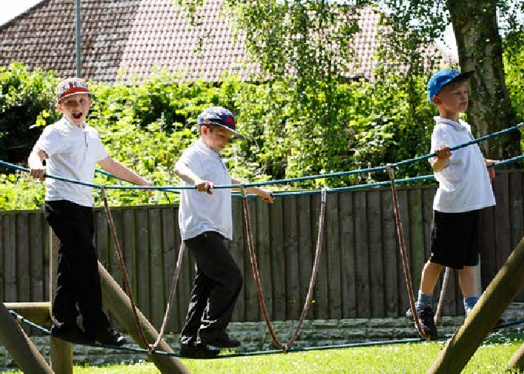

Hello
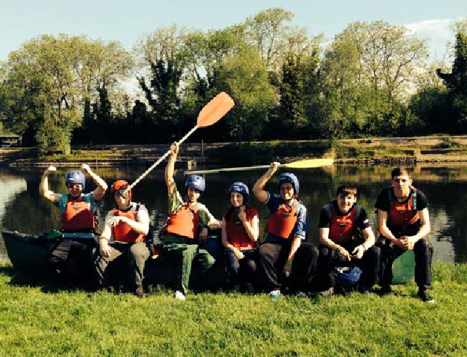



Firstly, thank you for your interest in working here at Royal School for the Deaf Derby. We know employment is a two-way relationship. The aim of this brochure is to help you decide if we’re for you. You can find out more about what we get up to on our web pages and Facebook pages here or, why not book an informal visit and see for yourself?

About our School
We are a unique provider of day and residential placements for young deaf learners aged 3 – 19, a speaking and signing community working hard to ensure all children and young people leave with the know-what and know-how to take their next steps into further education, employment or training.

At present we have 104 well behaved, hardworking children and young people on roll. Deaf children are cognitively as bright and brilliant as their non-deaf peers. Their experiences are at the heart of our curriculum and everyday practice. Some children and young people have complex special needs, in the context of our school this means a need in addition to deafness for example, deafness and autism.

The reputation of the School as a lead practitioner in deaf education is established together with positive
relationships with over 25 Local Authority placing partners drawn from a national catchment area. In December 2024 the School was judged solidly Good by Ofsted and in December 2025 the residential provision was judged Outstanding for the second year in a row. Our aspiration is to mirror the residential outcome at our next Ofsted education visit.

Increasing confidence in the quality of teaching, learning and care is apparent amongst all stakeholders. We are a well run Charity consistently rated as outstanding for our financial health. Our success is driven by qualified, competent and confident staff.

Continuing Professional Development
All staff enjoy a bespoke continuing professional development programme starting with a comprehensive induction package. An in-house, expert, British Sign Language (BSL) team support all staff to achieve the level of BSL needed for their role from beginners through to Level 6. All groups of staff are sponsored to achieve appropriate underpinning qualifications for their role.
Over the last academic year we have sponsored staff to achieve advanced diplomas in supporting teaching and learning, health and social care, Communication Support Worker with Deaf people, MA Teacher of the Deaf – to name but a few. An in-house specialist team made up of highly specialist Speech and Language Therapists, Audiology, subject specialist Teachers of the Deaf, Early Years practitioners, social care workers (including a qualified Social Worker), wellbeing and attendance team provide exceptional opportunities to learn through collaboration as part of the team around every child.

Employer of Choice
Our aspiration is to become an employer of choice. All Teachers are employed on the School Teacher’s Pay and Conditions Document and automatically enrolled into the Teacher’s final salary pension scheme. Terms and conditions for other child contact staff mirror these for example, a standard working week of 32.5 hours for education assistants, 13 weeks paid holiday leave entitlement (14 for Transition Support Communicators), 7.2 weeks holiday entitlement for non-child contact staff from day one and automatic enrolment into a workplace pension scheme for all.
Key Information:
Role: Education Assistant

Salary: £27,204 - £28,017 PA

Closing date for applications: Ongoing – please apply as soon as possible

Interviews: TBC

We are committed to safeguarding children and young people. Applicants for all roles are required to apply for an enhanced criminal background check as a minimum. Following changes to KCSIE 2022 RSD Derby will also undertake an online search as part of due diligence checks on shortlisted candidates to help identify any incidents or issues that have happened and are publicly available.

How to apply
Download job details and application documents from our website at, https://www.rsdd.org.uk/careers

To request an informal visit or discussion please contact Kristy Orpwood, PA to the Headteacher at Royal School for the Deaf Derby Ashbourne Road, Derby DE22 3BH, Voice & BSL: (WhatsApp) 07500 878565hildren Safe in



"Our vision is to be the leading specialist provider of education and care to D/deaf children and young people enabling them to achieve their full potential and lead independent and fulfilling adult lives."

 | 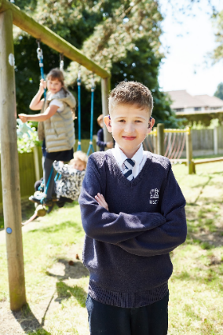 | 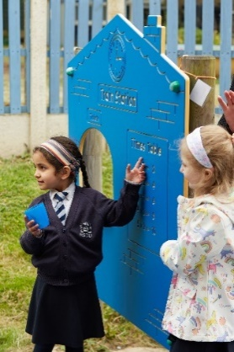
Education Assistant
Full Time (32.5 hours per week)
£27,204 – £28,017 pa (actual i.e. not pro rata)

Royal School for the Deaf Derby is a unique day and residential special school, a speaking and signing community that values English and British Sign Language equally. We are committed to promoting a positive sense of identity and ensuring all pupils of all abilities achieve their potential.

The role has a specific focus on supporting teaching and learning for individual and small groups of children to ensure and secure the best progress of each child from their starting point. British Sign Language Level 2 (or native user) and an appropriate underpinning qualification in supporting teaching and learning for the children’s workforce are highly desirable though opportunities for training are available.

All teaching and learning is supported by a team of competent, qualified and confident in-house specialists including Highly Specialist Speech and Language Therapy, subject specialist Teachers of the Deaf, Audiologist, and a wider team of education assistants.

We are committed to work life balance. All education assistants enjoy a working week based on 32.5 hours (full time equivalent) and 13 weeks paid holiday leave entitlement. All staff enjoy a personalised continuing professional development plan.

This role is a Regulated Activity under the Safeguarding Vulnerable Groups Act and subject to safer recruitment checks. These include an enhanced criminal record check through the Disclosure and Barring Service. This role is exempt from the Rehabilitation of Offenders Act 1974 (Exceptions) Order 1975 (as amended) Please see our policy statement on the recruitment of ex-offenders available on our jobs pages. Following changes to Keeping Children Safe in Education (KCSIE 2024) RSD Derby will also undertake an online search as part of due diligence checks on shortlisted candidates to help identify any incidents or issues that have happened, and are publicly available.

Further job details and application documents can be downloaded from our website at, https://www.rsdd.org.uk/careers You can also request these and/or arrange an informal discussion or visit by contacting Kristy Orpwood, Administration Lead & PA to the Headteacher, at Royal School for the Deaf Derby Ashbourne Road, Derby DE22 3BH Voice: 01332 362512 Email: Kristy.Orpwood@rsdd.org.uk BSL (WhatsApp) 07500878565

Role Specification
Title of Role

Education Assistant (Primary or Secondary Department)

Overall Purpose of the Role
- To support the teaching and learning of pupils including children with complex Special Educational Needs

Line Management Supervision
To whom: Senior Education Assistant (Primary or Secondary)
For whom: Shared responsibility with classroom teachers for volunteers or students on placement allocated to your class

Functional Relationships
- Other Education Assistants and Teachers
- Complex Special Educational Needs Co-ordinator
- Specialist Speech and Language Therapist, Educational Audiologist and Health Centre Lead
- External professionals participating and advising the team around the child at RSD Derby

Summative Duties and Responsibilities

- To establish a purposeful learning environment where children and young people feel engaged and confident; where diversity is valued and opportunities to learn are not missed
- To deliver individualised programmes of therapy and learning as directed by professionals; to deliver these programmes with confidence and autonomy
- To collect data to monitor, evaluate and reassess strategies on a regular basis to help determine their effectiveness in liaison with the team around the learner
- To actively participate in using a range a positive options to effect positive behaviour change for individual and small groups of learners
- To be realistic, consistent and supportive in responding to pupil’s behavioural needs
- To encourage and foster pupils’ skills of self-monitoring and self-control
- To work on a one: one basis with identified children to engage them in teaching and learning when needed
- To participate in team meetings to devise strategies for the social, emotional and behavioural development of learners
- To follow the School’s policies and procedures relating to the behaviour, emotional and social development of pupils at all times
- To participate in team meetings to develop strategies to deal with challenging behaviours both within and outside of the School day
- To identify, implement and evaluate individualised behaviour plans in liaison with the Behaviour Lead

- Assist with tracking learner progress and identify appropriate interventions in liaison with the appropriate professional expert
- To provide a positive role model for children presenting with challenging behaviours and be a key worker for identified children
- To build positive relationships with disaffected pupils to support their inclusion in the classroom and wider school community
- To proactively identify and de-esculate potentially challenging situations
- To undertake continuing professional development activities including general and pupil specific PROACT-SCIPr-UK® training on a regular basis
- To identify and undertake continuing professional development activities aimed at supporting pupil’s with complex special educational needs make outstanding social, emotional and educational progress
- To exploit opportunities for all learners, including those with social and emotional barriers to learning, to develop independence and know-how through promoting a variety of opportunities to learn within and outside of the classroom
- To deliver and assist with educational, personal, social and behavioural programmes for pupils in conjunction with other team members to ensure learners make progress
- To liaise and feedback on the social, emotional and behavioural progress of pupils to parents and carers in liaison with the Departmental Co-ordinator
- Prepare and modify teaching and learning resources
- Find out about and align support with, the communication profiles of individual pupils
- Following appropriate training and support, to administer medicines and undertake medical interventions
- Supervise pupils during break times and participate in enrichment activities at the end of the day
- Develop positive professional relationships with pupils, parents and other professionals
- Assist teachers to mount display work and information for pupils and visitors
- To help prepare for, and participate in, whole school and departmental events for example, Celebration Day and the Christmas drama
- To carry out any reasonable duties within the overall function commensurate with the grading and level of responsibility of the job
- The ability to work across the whole age range within school with appropriate support and guidance

Experience | Essential | Desirable
Supporting teaching and learning for young deaf learners with complex special educational needs |  | •
Delivering aspects of individual support plans / programmes of therapy as directed by professionals for example, speech and language therapists |  | •
Contributing to Individual Learning Plans and helping to track learner progress |  | •
Using a range of strategies to resolve potentially challenging behaviours | •
Putting SEND legislation into practice for the benefit of children and young people | •

Knowledge | Essential | Desirable
A range of positive strategies and interventions to support the progress of learners educationally, socially and emotionally | •
The effects of specific types of communicative behaviour, e.g. proximity, tone and gesture, and non-verbal behaviour, e.g. body language, personal space, on pupils’ emotional and behavioural responses, and how positive examples of these can improve pupils’ self-esteem and social response |  | •
How classroom and group dynamics can contribute to, accentuate or reinforce good/poor self-image |  | •
The rights of the children and young people including the right to be treated with dignity and respect | •

Skills | Essential | Desirable
Able to build positive and constructive relationships with children | •
Able to work autonomously and on a one: one basis to deliver individualised learning and therapy programmes as directed by professionals | •
Good communication in both British Sign Language and English or willing to undertake training upon appointment | •
Ability to work in a non-judgemental and confidential manner | •
Able to use strategies for rebuilding damaged emotional relationships between adults and pupils, and between pupils and their peers | •
Ability to promote good team working, support colleagues and remain professional at all times | •
Ability to create and maintain a positive learning environment where children feel safe, happy and engage in teaching and learning | •
The ability to reflect on own behaviour for example, the importance of modelling the behaviour you want to see and the implications of this for your own behaviour | •

Qualifications | Essential | Desirable
An appropriate underpinning Level III (or above) qualification in supporting teaching and learning (or willing to start training immediately) | •
British Sign Language Level II (or native user or willing to start training immediately) | •
Willingness to work towards a minimum British Sign Language Level III accredited qualification | •
GCSE English grade A-C or equivalent or willing to start training immediately | •
GCSE Maths grade A - C or equivalent above or willing to undertake training | •
Level 2 qualification in ICT for example, ECDL, IBT II |  | •
Educated to degree level or equivalent |  | •

Other | Essential | Desirable
The health and physical capacity to provide continuity of support for teaching and learning as set out in The Education (Health Standards) (England) Regulations 2003 | •
Appropriate assertiveness and negotiation skills for working with young people | •
Able to lead by example in promoting a positive role model for children and colleagues | •
Emotionally resilient, able to remain calm when faced with sensitive/emotional matters and when working under pressure | •
Motivated to take responsibility for own continuing professional development (CPD) and participate in whole school and departmental CPD sessions | •


