
WINTER 2025
ROYAL SCHOOL FOR THE DEAF
“What’s for Lunch....Week 3”

MONDAY | TUESDAY | WEDNESDAY | THURSDAY | FRIDAY
MAC & CHEESE PASTA BAKE  JACKET POTATO WITH  TUNA MAYO & CHEESE  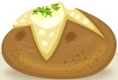 | CHEFS CHOICE CURRY  CHICKEN/QUORN/HALAL (H) (V)  JACKET POTATO WITH  CHEESE OR CURRY  NAAN BREAD | ROAST BEEF/QUORN/HALAL CHICKEN  GRAVY  JACKET POTATO  WITH  CHEESE | PORK & SAUSAGES  QUORN SAUSAGE (V) HALAL SAUSAGE (H)  &  GRAVY  JACKET POTATO WITH TUNA MAYO & CHEESE (V) | BREADED CHICKEN BURGER  HALAL BURGER (H) OR QUORN BURGER (V)  JACKET POTATO WITH  CHEESE OR BEANS  
GARLIC SLICE  SWEETCORN | RICE  BROCCOLI  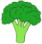 | ROAST POTATOES  GREEN BEANS  &  CARROTS   | MASHED POTATOES  CAULIFLOWER  & PEAS | SPICY WEDGES  BAKED BEANS
SALAD BAR  HARDBOILED EGGS  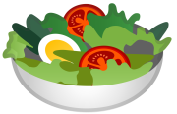 | GARDEN SALADS  PASTA SALAD | SALAD BAR  TUNA MAYO OR CHEESE | GARDEN SALAD  TUNA MAYO | SALAD BAR  HAM & CHEESE
APPLE CRUMBLE & CUSTARD | CHOCOLATE  BROWNIE | “FRUITY WEDNESDAY”  APPLE/ORANGE JUICE  SELECTION | STEAMED SYRUP SPONGE PUDDING & CUSTARD | CHEFS CHOICE FRIDAY
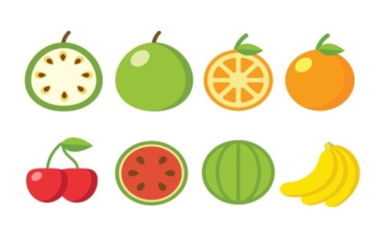Bread, Fresh Fruit & Yogurt - Available Every DayV1
ROYAL SCHOOL FOR THE DEAF
ALLERGENS WINTER OCT 2025 WEEK 3 V1

MONDAY | TUESDAY | WEDNESDAY | THURSDAY | FRIDAY
MAC & CHEESE PASTA BAKE (CONTAIN MILK, EGG, WHEAT & DAIRY)  JACKET POTATO WITH  CHEESE, TUNA MAYO (FISH/EGG, MUSTARD)  (CONTAINS MILK) | CHEFS CHOICE CURRY  HALAL/QUORN  (ASK AT COUNTER)  JACKET POTATO WITH CHEESE OR CURRY  (CONTAINS MILK, ASK AT COUNTER) | ROAST QUORN  (CONTAINS DAIRY & EGGS)  JACKET POTATO WITH TUNA MAYO OR CHEESE  (CONTAINS FISH, MILK, DAIRY, EGG, MUSTARD) | PORK/QUORN/HALAL SAUSAGES  (CONTAINS GLUTEN, CEREALS)  JACKET POTATO WITH TUNA MAYO OR CHEESE  (CONTAINS FISH, MILK, DAIRY, EGG, MUSTARD) | BREADED CHICKEN HALAL/QUORN BURGER  (CONTAINS DAIRY, EGG & GLUTEN)  JACKET POTATO WITH CHEESE & BEANS  (CONTAINS MILK, SULPHUR & SULPHITES)
GARLIC SLICE  (CONTAINS WHEAT, DAIRY) |  |  | MASHED POTATOES  (CONTAINS MILK)
HARDBOILED EGGS  (CONTAINS EGG) | PASTA SALAD  (CONTAINS GLUTEN MUSTARD, MILK & EGG)  HARDBOILED EGGS  (CONTAINS EGG) | TUNA MAYO OR CHEESE  (CONTAINS FISH, MILK, DAIRY, EGG, MUSTARD) | TUNA MAYO  (CONTAINS FISH/EGG/MUSTARD | CHEESE  (CONTAINS MILK)
APPLE CRUMBLE & CUSTARD  (CONTAINS MILK, GLUTEN) | CHOCOLATE BROWNIE (CONTAINS GLUTEN, EGG, MILK) |  | STEAMED SYRUP SPONGE & CUSTARD (CONTAINS GLUTEN, EGG, MILK) | CHEFS CHOICE FRIDAY  (ASK AT COUNTER)
IF UNSURE ALWAYS CHECK WITH THE COOK

WINTER 2025
ROYAL SCHOOL FOR THE DEAF
“What’s for Lunch....Week 2”

MONDAY | TUESDAY | WEDNESDAY | THURSDAY | FRIDAY
‘MEAT FREE MONDAY’ PASTA (V)  WITH TOMATO OR CHEESE SAUCE  JACKET POTATO WITH CHEESE (V)  TUNA MAYO | CHILLI BEEF/QUORN (V)/HALAL (H)  TACOS  JACKET POTATO & CHEESE (V) or CHILLI | GAMMON & PINEAPPLE RING  QUORN ROAST  HALAL CHICKEN  JACKET POTATO WITH CHEESE | HOMEMADE CHICKEN PIE  QUORN/HALAL PIE (V)    JACKET POTATO WITH  WITH CHEESE (V)  TUNA MAYO | FISH/VEGGIE BURGER  CHEESE SLICE  JACKET POTATO WITH CHEESE & BEANS  
PEAS  & GARLIC SLICE (V) | PLAIN RICE  GARDEN PEAS    SWEETCORN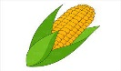 | ROAST POTATOES    CAULIFLOWER & CARROTS  GRAVY | CREAMED POTATOES  BROCCOLI  GRAVY | SPICY WEDGES  REDUCED SUGAR AND SALT BAKED BEANS
SALAD BAR  CHEESE & HARDBOILED EGGS | GARDEN SALADS  PASTA SALAD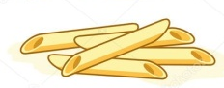 | SALAD BAR WITH  EGGS, CHEESE & RICE SALAD | GARDEN SALADS    HARDBOILED EGGS  TUNA MAYO | SALAD BAR  WITH  HAM & CHEESE
ICED RING DOUGHNUTS | COCONUT SPONGE & CUSTARD | FRUITY WEDENESDAY  APPLE/ORANGE JUICE | SHORTBREAD & CUSTARD | CHEFS CHOICE FRIDAY
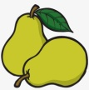 Fresh Fruit, Yogurt & Bread - Available Every Day  V1
WINTER 2023
ROYAL SCHOOL FOR THE DEAF
“What’s for Lunch....Week 3”

MONDAY | TUESDAY | WEDNESDAY | THURSDAY | FRIDAY
BREADED FISH & TARTAR SAUCE & LEMON WEDGES  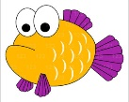  VEGGIE FINGERS (V)  JACKET POTATO WITH  CHEESE | MEAT FREE NUGGETS  (H) (V)  JACKET POTATO WITH  CHEESE OR BEANS | COTTAGE PIE  QUORN COTTAGE PIE (V)  GRAVY  JACKET POTATO  WITH COLESLAW OR MINCE MIX | PORK & CARROT MEATBALLS  QUORN MEATBALLS (V) WITH TOMATO SAUCE OR GRAVY  JACKET POTATO WITH TUNA MAYO & CHEESE (V) | HOMEMADE BURGER  HALAL BURGER (H) OR QUORN BURGER (V) IN A BRIOCHE BUN  SALSA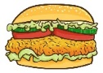  JACKET POTATO WITH  CHEESE OR BEANS
NEW POTATOES  PEAS | MASHED POTATOES  SWEETCORN | MASHED POTATOES  CARROTS & BROCCOLI | RICE  GREEN BEANS | NEW POTATOES  BEANS
SALAD BAR  HARDBOILED EGGS | GARDEN SALADS  EGGS  POTATO SALAD | SALAD BAR  COLESLAW & PASTA SALAD | GARDEN SALAD  TUNA MAYO | SALAD BAR  RICE SALAD  HAM & CHEESE
CREAMED RICE PUDDING & PEACH SLICES OR JAM | LEMON SPONGE & CUSTARD | “FRUITY WEDNESDAY”  FRESH FRUIT  SELECTION | CHEESE & CRACKERS, APPLE SLICES & GRAPES | HOMEMADE COOKIE  & MILK
Bread, Fresh Fruit & Yogurt - Available Every Day

