Come and join a School where, “Children benefit from exceptionally good relationships with staff, who know them incredibly well. The staff are highly skilled. They nurture the children and provide emotional warmth. Staff are excellent role models for the children” Ofsted 2024

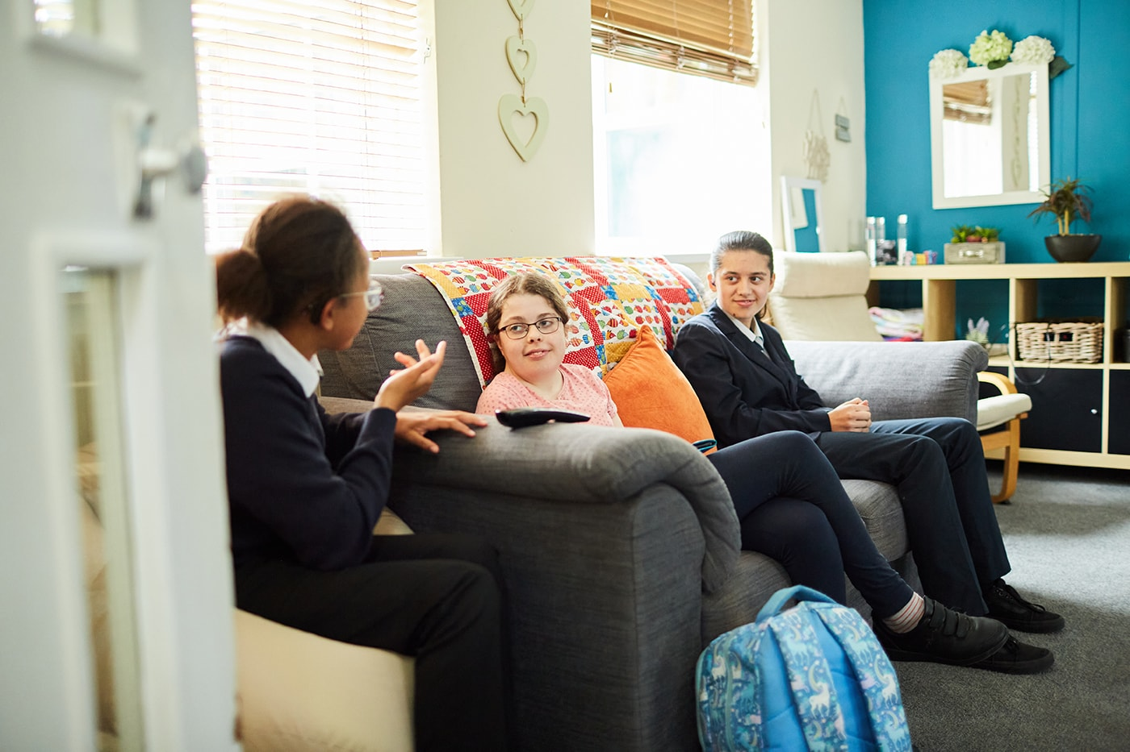

Title of Role
Wellbeing Lead Teacher/ Deputy Designated Safeguarding Lead

Line Management
Responsible to: Deputy Headteacher and Designated Safeguarding Lead

Summary Terms and Conditions

M1 – M6 +SEN 1

Key Purpose
- To champion and support the mental health, wellbeing of children and young people through facilitating a safe, calm and supportive learning environments
- To be the Deputy Designated Safeguarding Lead
- To encourage positive behaviour choices by supporting PROACT- SCIP techniques within the team
- To develop and oversee interventions that improve not only mental health and wellbeing but more broadly improved attainment, attendance and resilient children and young people and to keep abreast of best practice by understanding and implementing government guidance and initiatives
- To support improving attendance across the school in consultation with SLT and develop attendance strategies in accordance with best practise and government guidance
- To undertake a minimum of 0.2 FTE timetabled teaching (curriculum subject to be negotiated)
- To ensure the best possible learning outcomes for pupils of all abilities in your teaching groups

Supervisory Responsibilities
Responsible to: Deputy Headteacher (Designated Safeguarding Lead)
Responsible for: Wellbeing Champions

Functional Relationships
- Deputy Headteacher/ Designated Safeguarding Lead/ Senior Mental Health Lead
- Wellbeing Champions
- Wellbeing Team
- Senior Leadership Team
- Special Educational Needs Coordinator
- Department Leads
- Teachers and Educational Assistants

Main Duties and Accountabilities

- To develop, implement, monitor and evaluate the school’s strategic plan and interventions to improve the mental health and wellbeing across school to include the key principles below.
- Curriculum teaching and learning to promote resilience and support social and emotional learning
- Enabling the experiences and views of deaf children and young people to influence decisions
- Staff development to support their own wellbeing and that of students
- Identifying need and monitoring impact of interventions
- Working with parents and carers
- Targeted support and appropriate referral
- An ethos and environment that promotes respect and values diversity
- Have a good, secure working knowledge of a subject area within the National Curriculum
- To plan, prepare, evaluate and review lessons within school which reflect sound practice, recent professional developments and the needs of our students
- To have high expectations of students both academically and socially

- Liaise with key staff to discuss concerns regarding children and young people students whose mental health and wellbeing falls below expectations to identify, implement and monitor targeted interventions
- To be the first point of contact for external agencies supporting the mental health and wellbeing of children and young people including Deaf CAMHS
- Work closely with the school administration, safeguarding and teaching teams to understand and address the needs of absent children and young people to ensure they attend on a consistent basis
- To respond to requests from external partners for example, Local Authorities for absence data
- To produce regular reports on safeguarding, mental health, wellbeing, attendance and behaviour supported by robust data to evidence progress
- To meet with children and young people and their parents/carers to identify issues and concerns and put in place an appropriate plan to support children and young people to improve their mental and physical health, wellbeing, attendance and/or behaviour
- To ensure effective communication between all staff regarding identified pupils and between school and home.
- To develop effective 1:1 relationships with pupils and young people to enable positive rapport and the monitoring of progress towards agreed goals; work with individual and small groups of children and young people to deliver interventions
- To document progress against the starting points of children and young people’s mental health, wellbeing, attendance and behaviour capturing improvements over time and intervening if progress in these areas is not convincing
- To be an active member of the safeguarding team and respond to concerns raised by staff passing on any complex concerns to the Designated Safeguarding Lead; to deputise for the Designated Safeguarding Lead
- To take a lead role in the monitoring and evaluation of pupils’ personal development, welfare, behaviour and attendance and the quality of care and guidance over time leading to robust school improvement planning for safeguarding, wellbeing, behaviour and attendance
- To participate in annual review and behaviour monitoring processes including attending review meetings, contributing to reports, Education and Health Care Plans, risk assessments, behaviour management plans, care plans and intervention plans
- To attend safeguarding meetings for example, Children in Need, case reviews, serious case reviews, Team Around the Child and strategy meetings
- To promote the participation of staff (including self) in relevant continuing professional development
- To support good order and discipline amongst pupils and staff through the support and maintenance of a positive welfare and learning culture in residences and throughout the school
- To promote harmonious working relationships within the school including having proper regard for a work life balance for staff within legitimate expectations of their accountabilities
- To maintain positive relationships with external organisations where the school benefits from contact and networking. To collaborate and work with colleagues and other relevant professionals within and beyond the school including Local Authorities and the Derby Derbyshire Safeguarding Children’s Partnership
- To remain up to date with all local and national developments, relevant guidance and legislation and to advise colleagues appropriately
- To support the Headteacher according to the emerging needs of the school within the context of a reasonable balance between accountabilities and outside life

- To plan and deliver a curriculum (as discussed and agreed on interview) to assigned classes

Key: A: Application form I: Interview/selection & assessment activities R: reference and other employment checks C: Certificate

Education/training/qualifications | Essential/Desirable | Measured by:
Qualified Teacher Status | E | A/C
Qualified Teacher of the Deaf | D | A/C
Qualified Social Worker | D | A/C
Appropriate underpinning L5 Qualification for the Childrens’ Workforce | D | A/C
British Sign Language Level 3 or native/pre lingual British Sign Language User (or willing to start training upon appointment) | E | A/C
Evidence of regular and appropriate professional development | E | A/I
Experience of delivering a National Curriculum subject at a Key stage | E | A/C
Qualified PROACT-SCIPr-UK® Instructor or willing to train towards this as soon as practicable after appointment | D | A/I/C
Experience & Skills | Essential/Desirable | Measured by:
Significant recent and relevant experience of leading a team and raising standards | E | A/R
Experience of working effectively at a middle or senior leadership level in a Special School | D | A/I/R
Analysing data including tracking pupil behaviour data, identifying trends, evidencing school performance and improvement, target setting | E | A/I/R
The ability to investigate, solve problems, make and implement decisions | E | A/I/R
External Inspection regimes including Ofsted Education and Ofsted Welfare | E | A/I/R
Experience of attending safeguarding meetings such as CIN, TAC, serious case and strategy meetings | D | A/I
Annual Review processes, planning and transition arrangements | D | A
Excellent people management skills and competencies as set out in the School competency framework for people managers | E | A/I/R
Recent experience of planning, preparing, delivering and assessing in a National Curriculum subject area | E | A/I/R
Able to analyse data including tracking of pupil progress and trends, evidencing performance, improvement and target setting, for both academic and personal development | E | A/I/R
Knowledge & Understanding  Up to date knowledge and understanding of current and best practice including: | Essential/Desirable | Measured by:
Knowledge of best practice in managing the behaviour of children and young people with complex special educational needs | E | A/I
Strategies for raising pupils’ wellbeing and achievement (socially, emotionally and educationally) | E | A/I/R
Strategic planning linked to school improvement including attendance and behaviour for learning | E | A/I/R
Deaf Community and Context, educational provision for deaf children and young people | D | A/I
Current SEND legislation | E | A/I
Personal qualities | Essential/Desirable | Measured by:
Dedicated to the safeguarding and welfare of children and young people | E | A/I/R
Personal drive, enthusiasm and commitment to securing the best possible learning outcomes for every pupil | E | A/I/R
An open, transparent, collaborative approach to managing people and other resources | E | A/I
Fluent communication skills, the ability to persuade and influence others | E | A/I
Evidence of being able to build and maintain constructive relationships with children and young people, staff, parents and carers and the wider community | E | A/I
A good record of health, attendance and timekeeping | E | A/I/R
Able to argue ones case rationally | E | A/I
Able to manage own work-life balance and that of others | E | A/I
Physical and Mental Health | Essential/Desirable | Measured by:
The ability to perform all duties and tasks with reasonable adjustment, where appropriate, in accordance with the Equality Act 2010 | E | A/R
Own physical and mental health does not constitute any risk to the health, safety or well-being of children or jeopardise the continuity of support the role provides to them | E | A/R

